Case 1-Afr-Tanzania-Olduvai Gorge-Oldowan Culture-Pebble Tools-1.5 mya
Oldowan pebble tools, Olduvai Gorge, Tanzania,
"Oldowan Chert source [site] MNKCF" (B21),
dating between 1·65 and 1·53 million years ago.
Oldowan (Olduwan), is the earliest stone tool industry of Tanzania dating to the Lower Paleolithic period, 2.6 million years ago (m.y.a.) up until 1.7 m.y.a. The Olduvai Gorge was inhabited by ancient Homo habilis and later Homo erectus. "Oldowan" refers to the site in Olduvai Gorge, Tanzania, where the first Oldowan pebble tool industries are found. The Oldowan pebble tool industry is also referred to as "Mode 1" while "Mode 2" refers to the succeeding bifacial Acheulean hand axe industry. The site was excavated by Louis Leakey in the 1930s.
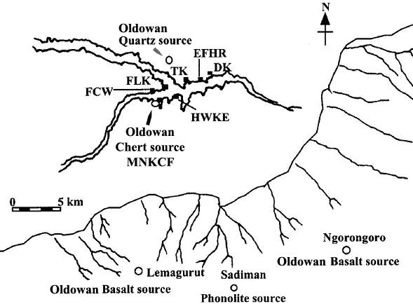
Fig. 1. Map of Olduvai Gorge, Tanzania. The "Oldowan Chert source [site] MNKCF" is the site of the artifacts in the current assemblage. Additional sites associated with ongoing excavations are labeled FCW, FLK, TK, EFHR, DK and HWKE. These are not treated in this paper.
The first classification of Oldowan pebble tools, so named because the blanks chosen for their production already resemble, in pebble form, the final product, was by Mary Leakey who classified Oldowan assemblages based on use were choppers, scrapers, and pounders (Clark et al. 1994; Leakey 1971). Another approach to classification of Oldowan assemblages focuses on manufacture using categories such as "Flaked Pieces" (cores/ choppers), "Detached Pieces" (flakes and fragments), "Pounded Pieces" (cobbles utilized as hammerstones) and "Unmodified Pieces" also known as manuports, stones transported to sites (Isaac, Harris, Marshall 1981).
The most probable hominin species who created and used Oldowan tools was Homo habilis, who had a slimmer build (five feet tall and 110 pounds) and smaller teeth than any known australopithecine and a larger braincase of 600 to 800 c.c., and hands with a fully opposable thumb. Homo erectus appears to have inherited this Oldowan technology from Homo habilis and refined it into the Acheulean industry beginning 1.65-1.53 million years ago.
In our sample of Oldowan pebble tools from the B21 "Chert source" site indicated on the map in figure 1, all three of Mary Leakey's types (choppers, scrapers, and pounders) are represented in this sample. This assemblage from Olduvai Gorge dates between 1·65 and 1·53 m.y.a. and shows a preponderance of chert utilization and suggests that early hominins at Olduvai may have been selective in applying distinctive manufacturing strategies as shown in Fig. 2 in making and using tools depending on the raw materials available from 1.87 m.y.a. to 1.27 m.y.a.

Fig. 2. Tool-using strategy at Olduvai Gorge between 1.87 and 1.27 m.y.a. after Kimura 1999: Fig 10, p. 825.
Although lava cores are prevalent at the Oldowan Chert source site, very few lava flakes have been found there, suggesting that these heavy,-unfinished lava cores were used as hammers and anvils, despite the fact that they have excellent flaking properties. However, chert flakes were abundant at the Oldowan Chert source site but large chert cores were few suggesting that chert cores were flaked to extinction and that chert flake production was the most important industry between 1·65 and 1·53 m.y.a. or .for a duration of ca. 120,000 years.
Oldowan technology produced chunky chert flakes by direct percussion using a lava hammer-stone. These lava hammer-stones were also used to refine an edge for cutting through animal hide to extract the meat of prey. Since meat provided a compact source of protein and calories for the Homo habilis diet, an adaptation evolved in which the gastro-intestinal tract had a proportionally larger stomach and smaller intestine than its predecessors the australopithecines. As Homo Habilis scavenged animal kills and hunted wild game, fruits, berries and nuts were also consumed (Kimura 1999, 2002).
Homo habilis also evolved a relatively larger brain case than australopithecines, which suggests more neural circuitry, lengthening the period of childhood development , and prolonging a period during which skills such as chert-knapping and coordinated hunting could be inculcated. Also, the stereoscopic vision of forward-looking eyes that Homo habilis evolved from arboreal ancestors suited a hunting behavior that required superior depth perception similar to that of leopards, saber-toothed cats and other extinct fauna with which Homo habilis competed for meat.
References
Kimura, Yuki. 1999. Tool-using strategies by early hominids at Bed II, Olduvai Gorge, Tanzania. • Journal of Human Evolution, 37: 6 (December): 807-831.

Kimura, Yuki. 2002. Examining time trends in the Oldowan technology at Beds I and II, Olduvai Gorge. Journal of Human Evolution, 43:3 (September):291-321

Clark, J.; de Heinzelin, J.; Schick, K.; Hart, W.; White, T.; WoldeGabriel, G.; Walter, R.; Suwa, G.; Asfaw, B.; Vrba, E.; et al. (1994). "African Homo erectus: Old radiometric ages and young Oldowan assemblages in the middle Awash Valley, Ethiopia". Science 264 (5167): 1907–1909.

Isaac, G. Ll., Harris, J. W. K. & Marshall, F. 1981. "Small is informative: the application of the study of mini-sites and least effort criteria in the interpretation of the Early Pleistocene archaeological record at Koobi Fora, Kenya." in Internacional de Ciencias Prehistoricas Y Protohistoricas, Mexico City. Mexico, pp. 101–119.

Leakey, Mary (1971). A Summary and Discussion of the Archaeological Evidence from Bed I and Bed II, Olduvai Gorge, Tanzania, pp. 431-460, in Glynn Isaac and Elizabeth Richards McCown, eds., Human Origins: Vol.3: Louis Leakey and the East African Evidence (Perspectives on Human Evolution), Reading, Mass.: Addison Wesley Longman, 1976.

